**Video Game Sales Analysis**

**GameCo Regional Budget Allocation 2017**

|  |
| --- |
| Requirements and Current Understanding GameCo are making plans for the 2017 regional budget allocation and would like recommendations on how best to allocate resources. It is GameCo’s current understanding that sales in the various regions have remained the same over time. |

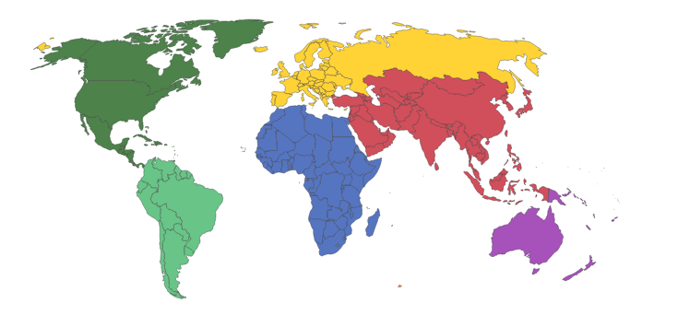

## What this Report Covers:

As part of this analysis the following areas will be covered:

* The data set used for the analysis.
* A summary of video game sales performance from 1994 to 2016 by region.
* A discussion into how the industry has performed, and possible reasons for any changes.
* A look at what each market is expected to do next by region.
* A plan for allocating GameCo’s marketing budget for 2017 by region.

Also discussed:

* Which genres of video game were most popular in each region between 2012 and 2016.
* Who of GameCo’s competitors performed best in each region.
* A summary of recommendations.

## The Data Set

The data set provided by VGChartz which spanned 30 years from 1980 to 2020 was assessed for completeness. An initial inspection showed that the number of recorded observations for the earlier and later years were not significant in volume compare to the number of observations recorded in the middle years. For example, there were only 9 sales observations recorded in 1980, compared to over 1000 observations being recorded in 2011.

For this reason, the data set year range was trimmed to include consecutive years where a significant number of observations existed (>100 observations) which resulted in a revised year range of 1994 to 2016.

## Gaming Industry Sales Performance

A preliminary analysis of video game unit sales by region from 1994 to 2016 showed that, as an overall picture, sales had peaked in 2008 for three out of four regions, and have slowly been on the decline in all regions ever since. The analysis also revealed that sales in North America contributed the greatest proportion to global sales for the majority of recorded years, refer to Figure 1.

Figure 1

Having revealed that video games sales have been on the decline since 2008 for all regions without exception, a more concentrated examination of the years following this peak showed that sales for all regions were potentially set to converge, meaning that North America no longer dominated the industry, refer to Figure 2.

Figure 2

## Changes in the Industry

Over the years, the gaming industry has moved from a product-oriented business, where games are purchased either physically or digitally, to gaming-as-a-service. Games are not just played off-line via console anymore but now many involve an on-line subscription to streaming services where games can still be purchased digitally but more likely played as part of the subscription, with multiple on-line players, all having access to all the latest material.

Gaming via mobile device has also been available for a number of years, and with the advent of the Smart phone arriving in 2007, the world of mobile gaming has become a firm feature.

Consideration of these modern revelations: gaming as a service, and mobile gaming; it is not difficult to understand how video game sales has declined.

## Present and Future Trends

Figure 3 shows a downward trend for video game sales between 2014 and 2016, although Figure 1 confirmed that this has been the case since 2008. Figure 3 is a magnified view of this situation so that a more details analysis can be drawn from that data. Taking into account that sales in general are on the decrease, the graph suggests that the following is true:

* Video game sales in the North American market will no longer dominate, and Europe is looking likely to edge in front.
* Sales in Japan and “Other” regions remain relatively steady.

Figure 3

Figure 4 shows the regional contribution to global sales as a percentage over 3 years (2013 to 2016), this graph confirms the insights stated above:

* It is looking probably that Europe will make the biggest contribution to global sales.
* Japan’s contribution will be a greater percentage as a result in the fall in North American sales.
* “Other” regions remain steady.

Figure 4

## Budget Recommendation

Based on the earlier findings, Figure 5 shows the recommended budget allowance per region.

Figure 5

## Further Information – Video Game Genre

Having revealed the suggested budget allocation for each region, it is worth noting Figure 6 below which shows the popularity of video game genre across the various regions. The graph has been ordered by popularity in Europe, as Europe has the largest budget allocation at 40%.

Figure 6

## Game Genre Recommendation

The table below summarizes the 1st and 2nd most popular genre of game by region. Given that Action is either 1st or 2nd for all regions, it is recommended that GameCo look to investing in this style of game.

|  |  |  |  |
| --- | --- | --- | --- |
| **Region** | **Budget Allocation** | **1st Most Popular Genre** | **2nd Most Popular Genre** |
| Europe | 40% | Action | Shooter |
| North America | 30% | Action | Shooter |
| Japan | 20% | Role-Playing | Action |
| Other Regions | 10% | Action | Shooter |

## Further Information – Video Game Publisher

There are hundreds of publishers on the market, many of which are barely make a dent in any of the regional markets. Figure 7 however shows the Publishers that perform in the Top Ten amongst the various regions, amounting to 17 publishers globally.

Figure 7

## Video Game Publisher Recommendation

A review of how some of these top publishers performed over recent years shows the same downward trend, and for that reason I would recommend that GameCo look to investing in other markets such as gaming-as-a-service, and consider what their competitors are doing in these markets as opposed to looking at a market which is dying.

## Summary

GameCo’s initially understanding of regional markets was that sales had generally stayed the same. However, an analysis of the sales figures provided by VGChartz showed fluctuations in sales across all regions, followed by a downward trend from 2008 for all regions. The analysis also revealed that where North America was the strongest region, contributing the most to global sales, Europe is now looking to be more prominent.

The following recommendations have been suggested:

* Allocate GameCo’s budget for 2017 as follows:
  + Europe 40%
  + North America 30%
  + Japan 20%
  + Other Regions 10%
* Pull resources into developing Action games to cater for all regions.
* Look to other markets for improving revenue such as providing gaming-as-a-service, and consider how competitors are performing in these areas.